**Cover Page**

**CSCI 2272 - Computer Organization and Lab**

**Lab Report 5**

**Lab Number and Name:**

**Student 1 Name and BC Email: Grace Wagner - wagnerge@bc.edu**

**Student 2 Name and BC Email: Jonathan Nushi - nushi@bc.edu**

## Circuit 1

## Design

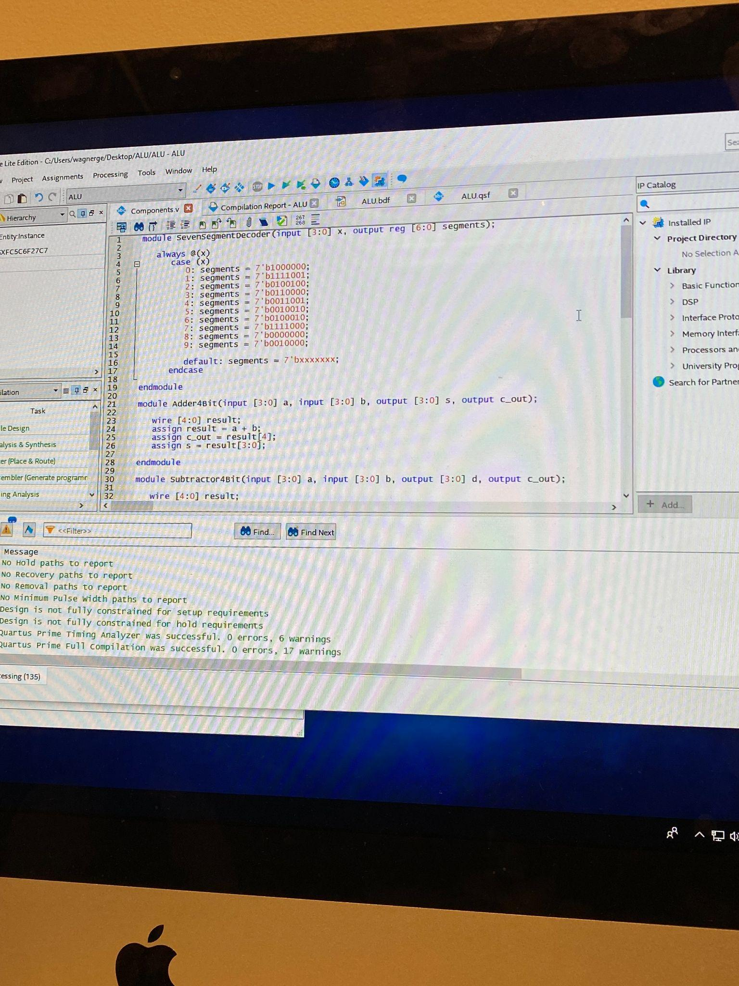

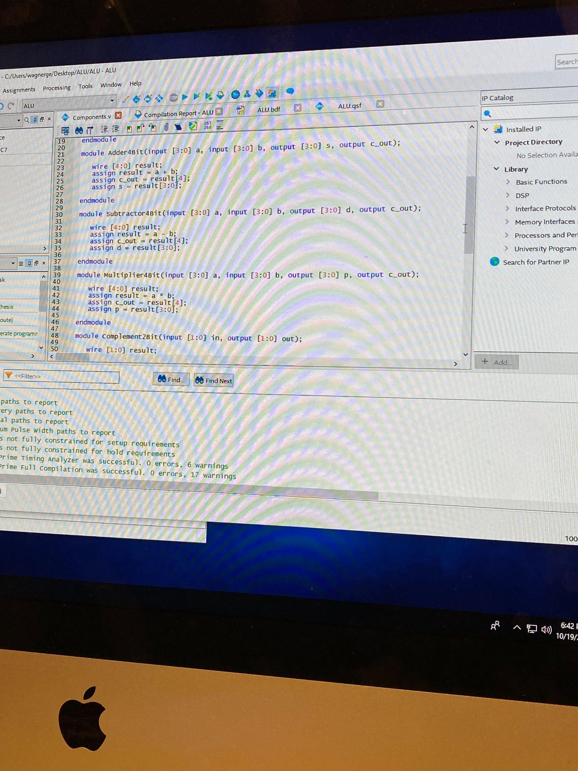

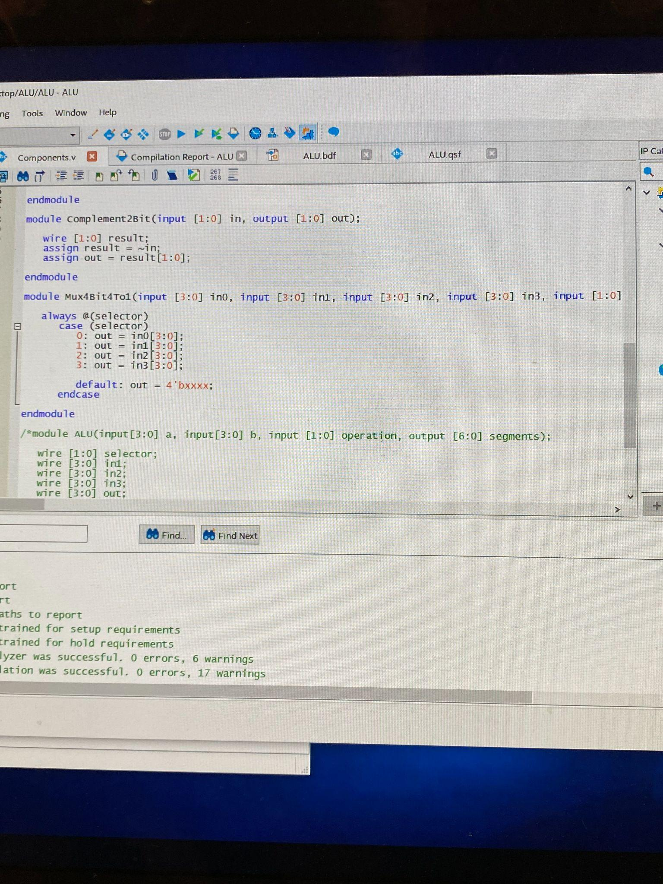

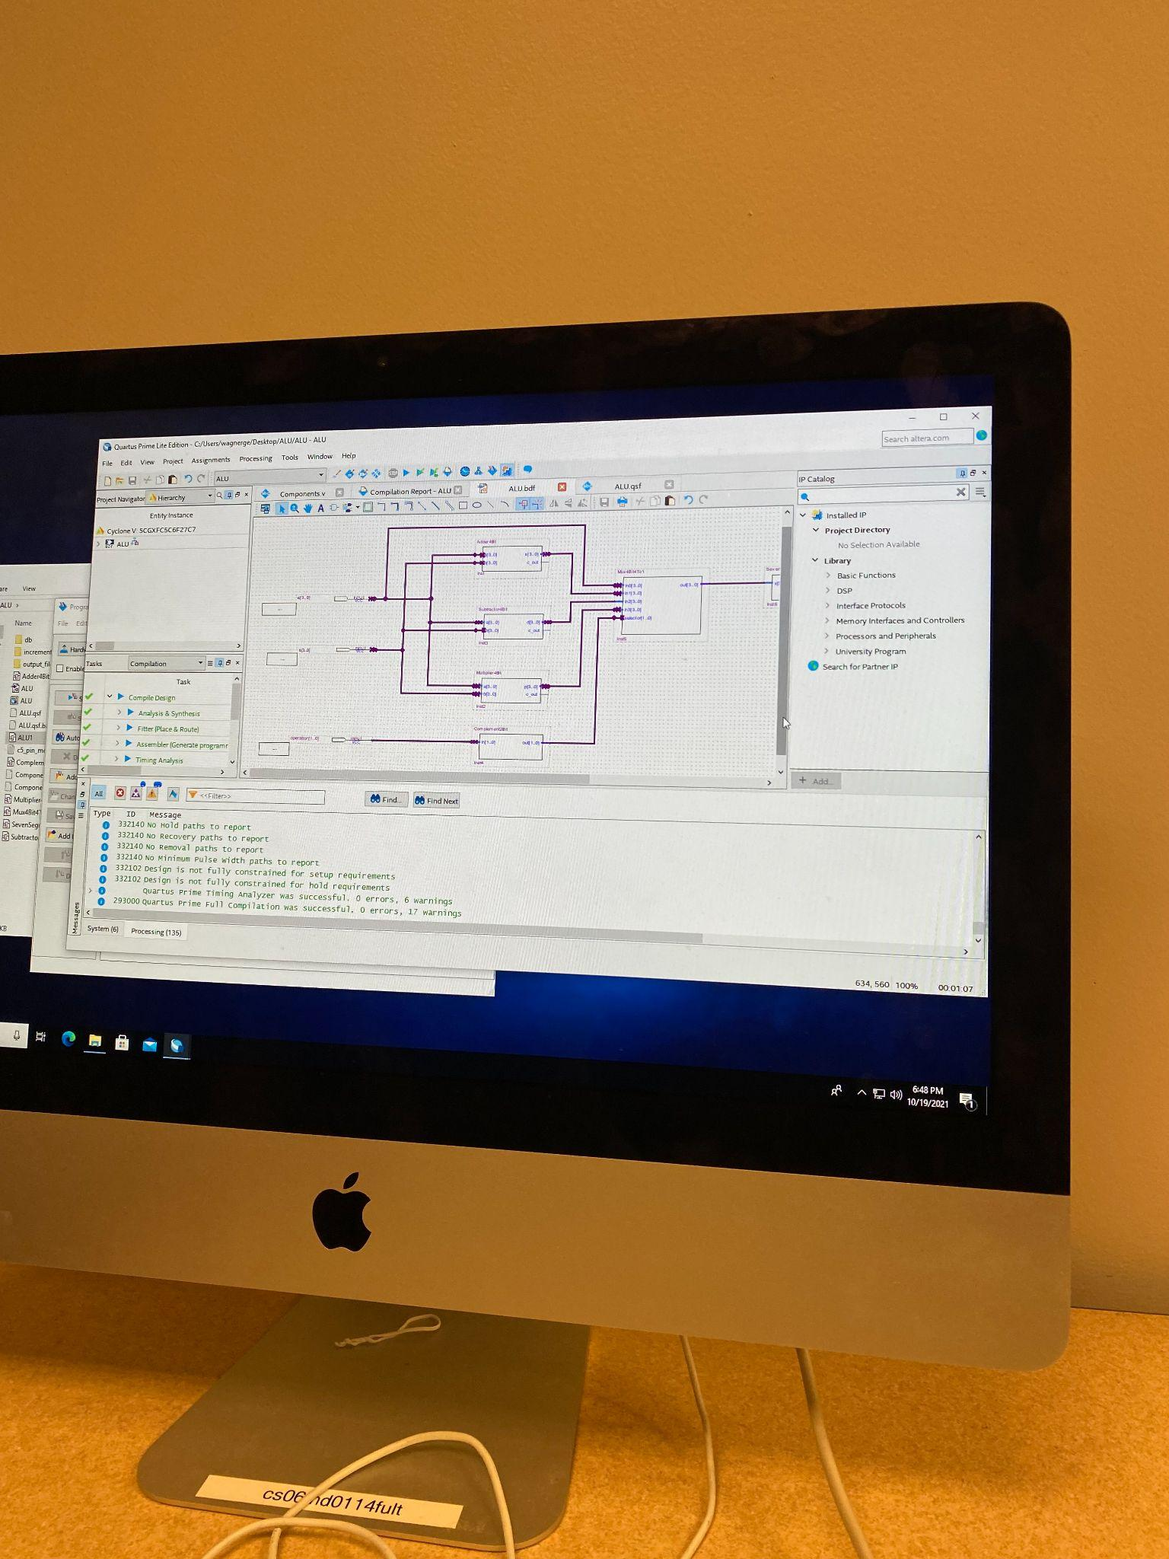

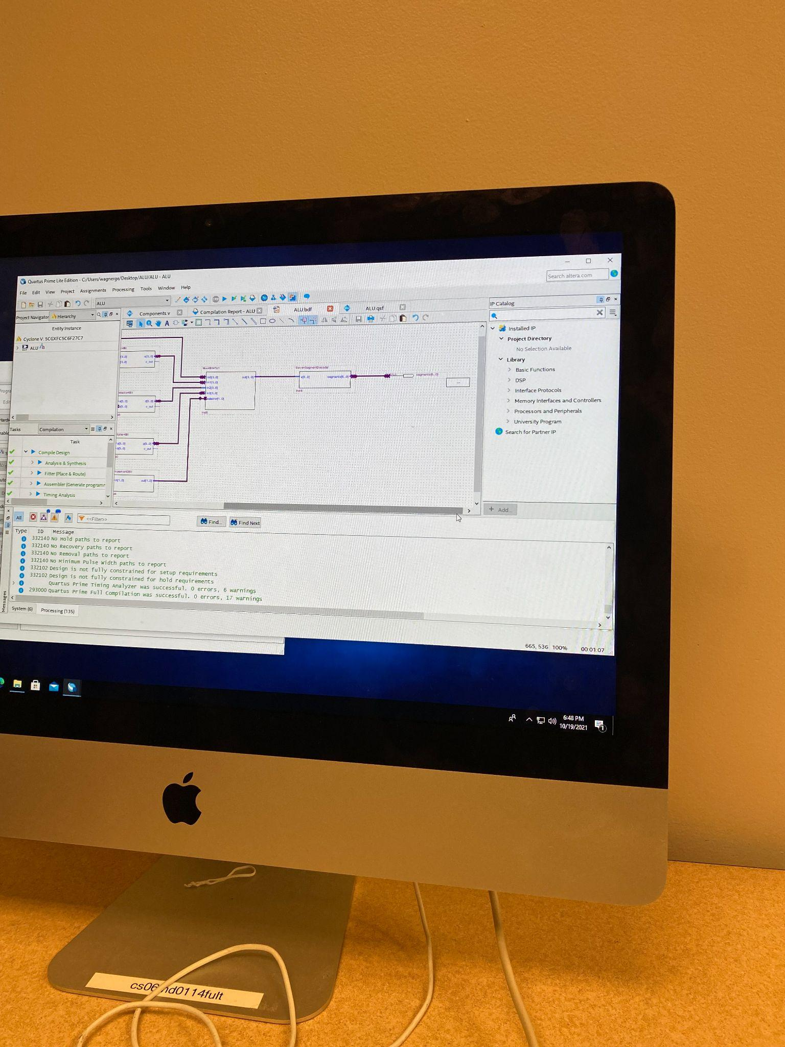

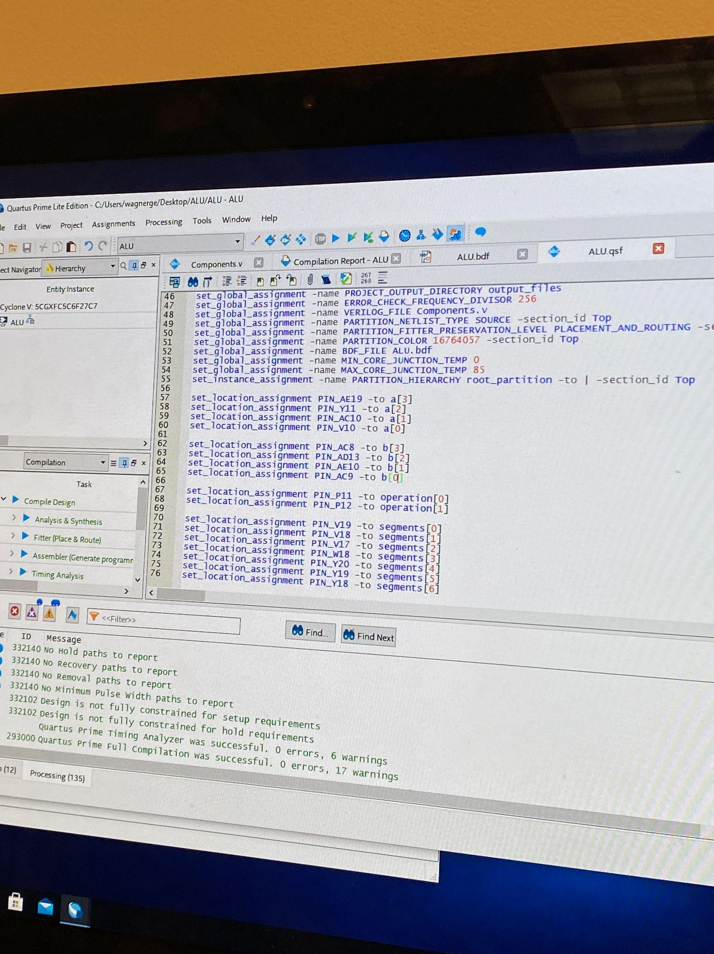

## Output

Take screenshots of your simulations for all your designs and paste them here. You should show that you tested all the possible inputs from the Truth Table.

Display:

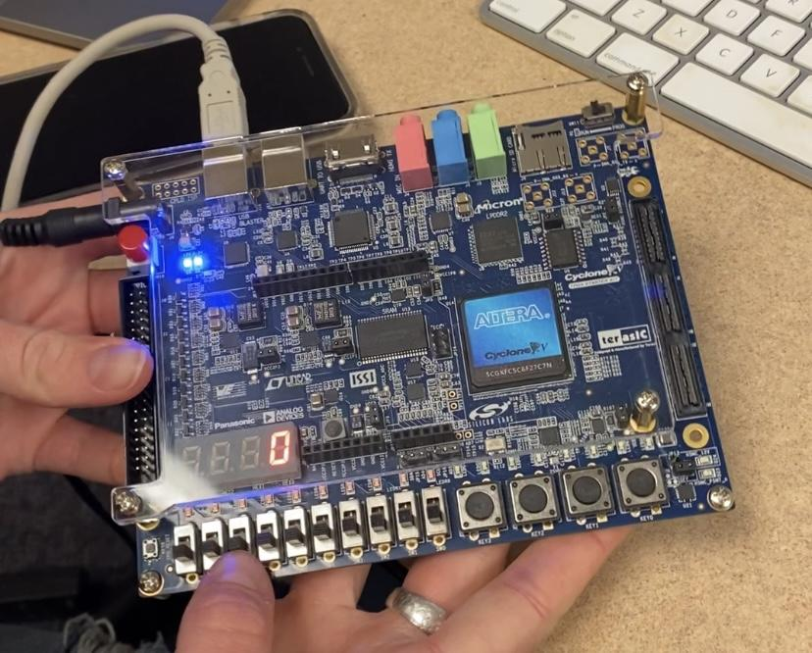

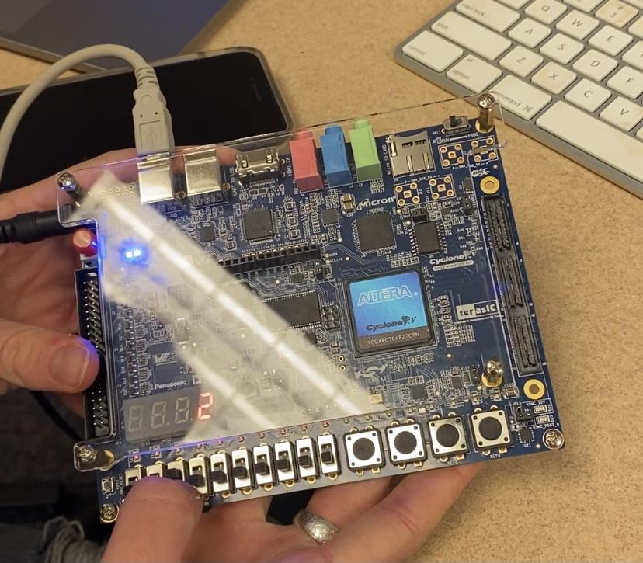

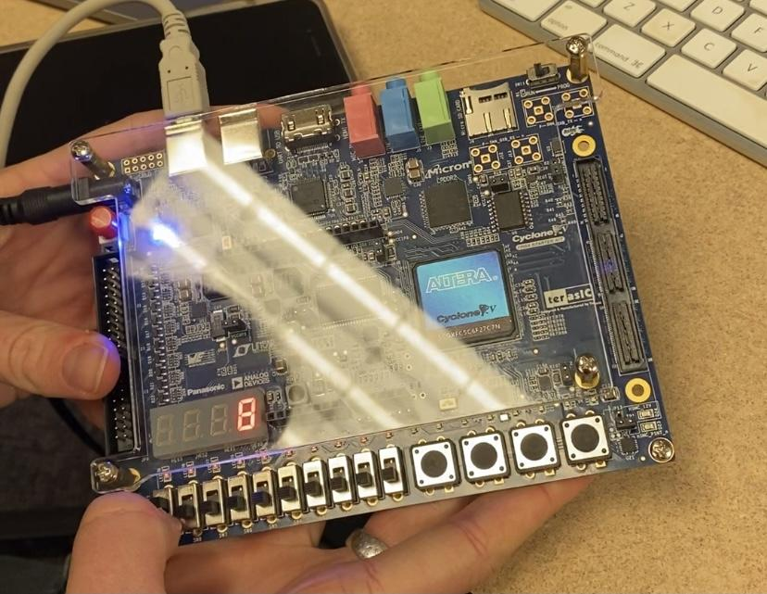

Addition:

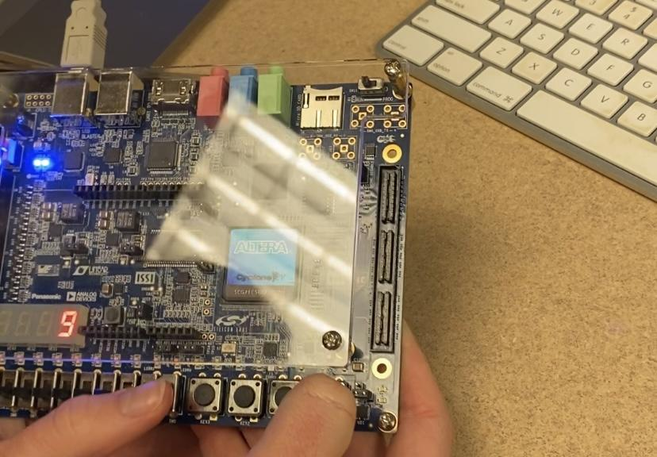

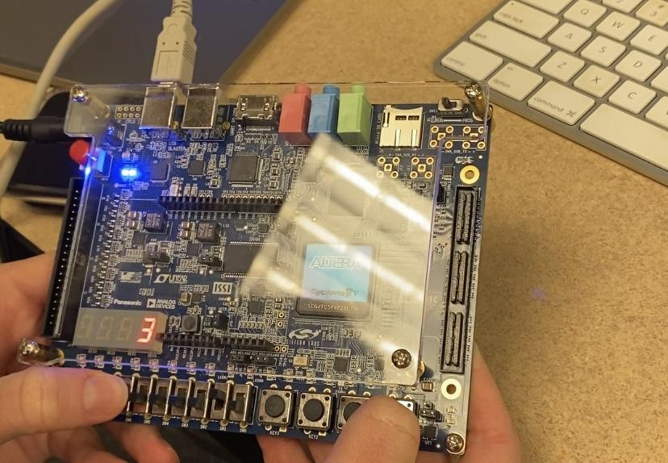

Subtraction:

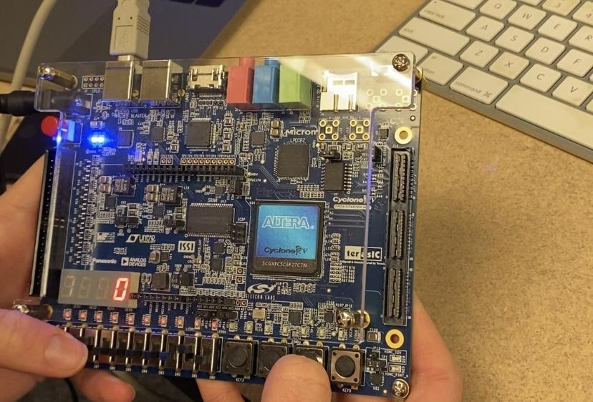

Multiplication:

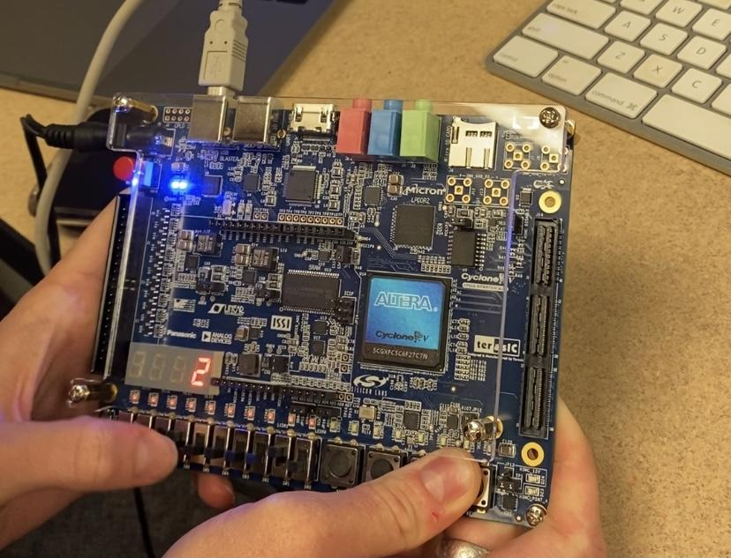

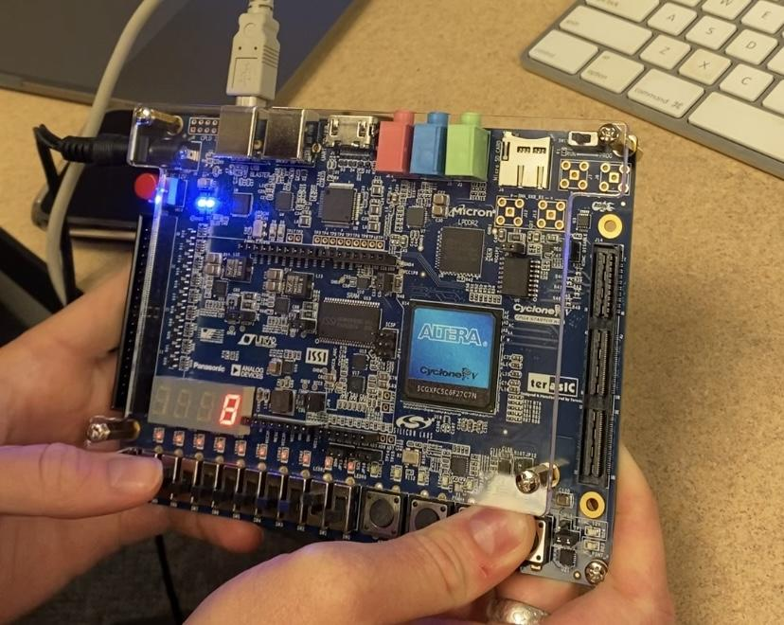

## Reflections

1. What did you learn from this lab?

We learned how to combine verilog code and schematic diagrams to perform arithmetic operations using the circuit board. We also learned more about the intricacies of verilog syntax.

1. What errors did you face and explain how you resolved them? Feel free to collect screenshots of errors or copy and paste them here?

We found an error in our code for the SevenSegmentDecoder. One of the bit combinations mapped to the integer input of the module was incorrect, so it resulted in an incorrect display on the board. We fixed this by double-checking the segment mappings in our code and correcting the one that was wrong. We also inverted the mappings of a0-3 and b0-3 to the board’s switches, which also resulted in an incorrect display on the board. We recognized that the numbers displayed on the board were backwards, so we fixed the pin mappings.

1. What tasks did each of you perform in the lab? You can say we both did everything together or if you divided tasks amongst yourself or some other way that you used to accomplish this lab?

Jonathan- Read the lab instructions and pin mappings aloud, set up the board, checked the code and block diagram for bugs/errors, and took pictures of the circuit design and output for the lab report.

Grace- Typed the code in verilog, created the block diagram of the circuit, and mapped the circuit outputs to the correct pins on the board.

1. What reference material did you use for this lab? If it was a resource from the web, please include it here.

We used the lab guide and the pin assignments provided. We also used a webpage that listed the different verilog operators that we could use: <https://class.ece.uw.edu/cadta/verilog/operators.html>.